SIMATS ENGINEERING
ASSESSMENT TOOL 1
COURSE NAME: Operating Systems
COURSE CODE: CSA-0409
NAME: Sruthi Rithika P
REG NO:192521407

COURSE OUTCOME COVERED
CO3: Evaluate memory management mechanisms such as linking, paging, and segmentation to determine their effectiveness for different system requirements
Assessment Tool Weightage: 40%

QUESTIONS: 5 Total Marks: 50
Experiment Questions:
1.Design and implement a program to simulate the translation of a logical address into a physical address using base and limit registers. The program should accept logical address as input, check for validity, and compute the corresponding physical address. Display appropriate messages for valid and invalid addresses.
2.Write a program to demonstrate the paging memory management scheme. The program should divide memory into fixed-size pages and frames, accept page number and offset as input, and compute the corresponding physical address using a page table.
3.Develop a program to simulate a page table. The program should allow the user to input page table entries and logical addresses, then map them to physical addresses. Clearly show how page numbers are translated into frame numbers.
4.Implement a program to simulate the working of a Translation Lookaside Buffer (TLB). The program should demonstrate how TLB improves memory access time by calculating the effective memory access time with and without TLB.
5.Write a program to illustrate memory protection using base and limit registers. The program should verify whether a given logical address lies within the valid range and prevent unauthorized access.
RUBRICS FOR CALCULATION:

Criteria | Weightage (Marks) | Level 4 – Exemplary (Full Marks) | Level 3 – Proficient | Level 2 – Developing | Level 1 – Beginning
Conceptual Understanding | 35 Marks | Demonstrates clear, complete, and in-depth understanding of OS concepts (types, structure, system calls) | Good understanding with minor gaps | Basic understanding with some misconceptions | Poor or incorrect understanding
Accuracy of Answers | 25 Marks | All answers are correct, precise, and relevant | Mostly correct with minor errors | Partially correct with noticeable errors | Mostly incorrect or irrelevant
Application of Knowledge | 15 Marks | Effectively applies concepts to scenarios/questions | Applies with minor mistakes | Limited or partial application | No meaningful application
Completeness of Response | 15 Marks | All parts of each question are fully answered | Most parts covered with small omissions | Some parts missing | Incomplete answers
Clarity & Presentation | 10 Marks | Clear, well-structured, and neatly presented answers | Understandable with minor issues | Somewhat unclear or poorly structured | Difficult to understand

Experiment 1: Logical Address to Physical Address Translation Using Base and Limit Registers

1. Aim
To design and implement a program that simulates the translation of a logical address into a physical address using base and limit registers, and displays appropriate messages for valid and invalid logical addresses.

2. Objective
- To understand logical and physical addresses.
- To understand the purpose of base and limit registers.
- To check whether a logical address is within the permitted range.
- To calculate the corresponding physical address for a valid logical address.
- To identify and reject invalid memory references.

3. Theory
A logical address is generated by the CPU during program execution. It must be translated into a physical address before accessing main memory.
Two registers are used for this purpose:
Base Register
The base register contains the starting physical address of the process in memory.
Limit Register
The limit register specifies the maximum size or valid range of the process's logical address space.
Address Translation
If:
- Logical Address = LA
- Base Address = Base
- Limit = Limit
Then:
Valid condition:
0 ≤ Logical Address < Limit
If the logical address is valid:
Physical Address = Base + Logical Address
If:
Logical Address ≥ Limit
then the address is invalid, and the operating system generates a protection error/trap.

4. Algorithm
- Start the program.
- Read the base address.
- Read the limit value.
- Read the logical address.
- Check whether the logical address is less than the limit.
- Ifvalid,calculate:
Physical Address = Base + Logical Address
- Display the physical address.
- Otherwise, display an invalid logical address message.
- Stop.

5. C Program
#include <stdio.h>

int main()
{
int base, limit, logical, physical;

printf("Enter Base Address: ");
scanf("%d", &base);

printf("Enter Limit: ");
scanf("%d", &limit);

printf("Enter Logical Address: ");
scanf("%d", &logical);

if (logical >= 0 && logical < limit)
{
physical = base + logical;

printf("\nAddress is VALID.\n");
printf("Logical Address : %d\n", logical);
printf("Base Address : %d\n", base);
printf("Limit : %d\n", limit);
printf("Physical Address : %d\n", physical);
}
else
{
printf("\nAddress is INVALID.\n");
printf("Logical address %d is outside the limit %d.\n",
logical, limit);
printf("Memory access denied!\n");
}

return 0;
}

OUTPUT:
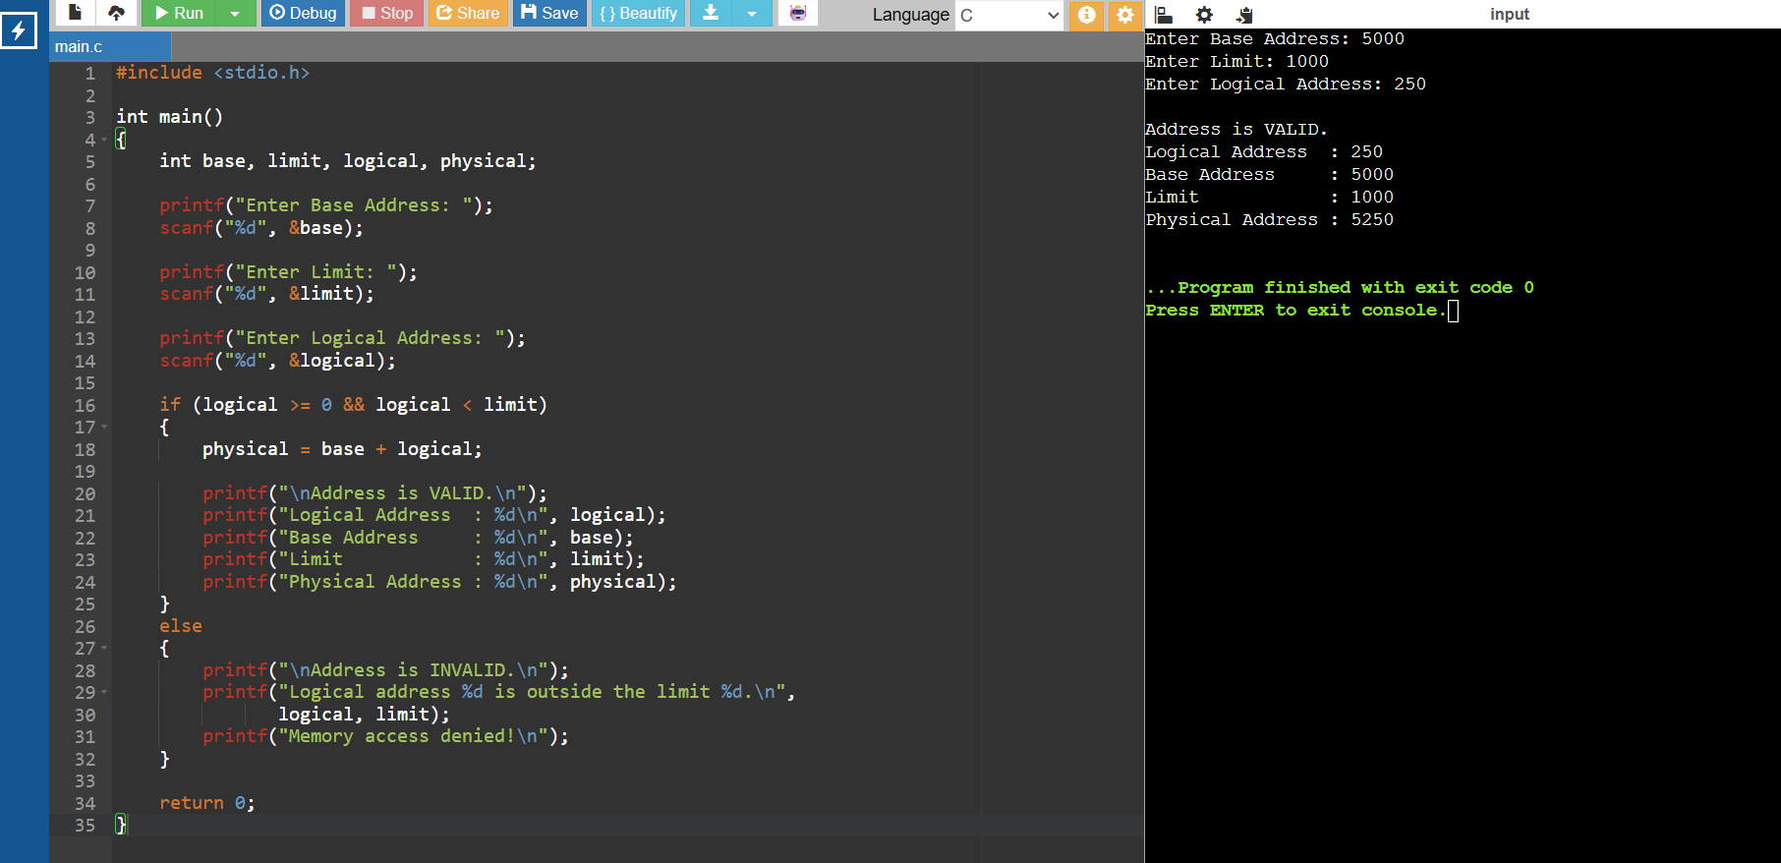

Result
The program successfully simulates logical-to-physical address translation using base and limit registers. It accepts a logical address, checks whether it lies within the permitted limit, calculates the physical address for valid addresses, and rejects invalid addresses to provide memory protection.

Experiment 2: Paging Memory Management

1. Aim
To write a C program to demonstrate the paging memory management scheme by dividing logical memory into fixed-size pages and physical memory into frames, and translating a logical address into a physical address using a page table.
2. Objective
- To understand paging memory management.
- To understand the relationship between pages and frames.
- To implement a simple page table.
- To calculate the physical address from a page number and offset.
- To detect invalid page numbers.

3. Theory
Paging is a memory management technique in which:
- Logical memory is divided into fixed-size pages.
- Physical memory is divided into fixed-size frames.
- Each page can be stored in any available frame.
- A page table maintains the mapping between page numbers and frame numbers.
The physical address is calculated using:
Physical Address = (Frame Number × Page Size) + Offset
For example:
Page Size = 100 bytes
Page Number = 2
Offset = 50
Frame Number = 5

Physical Address = (5 × 100) + 50
= 550

4. C Program
#include <stdio.h>

int main()
{
int pageSize, numPages;
int pageTable[20];
int pageNumber, offset;
int frameNumber, physicalAddress;
int i;

printf("Enter page size: ");
scanf("%d", &pageSize);

printf("Enter number of pages: ");
scanf("%d", &numPages);

printf("\nEnter page table (Frame number for each page):\n");

for (i = 0; i < numPages; i++)
{
printf("Page %d -> Frame: ", i);
scanf("%d", &pageTable[i]);
}

printf("\nEnter page number: ");
scanf("%d", &pageNumber);

printf("Enter offset: ");
scanf("%d", &offset);

if (pageNumber < 0 || pageNumber >= numPages)
{
printf("\nInvalid page number!\n");
}
else if (offset < 0 || offset >= pageSize)
{
printf("\nInvalid offset!\n");
}
else
{
frameNumber = pageTable[pageNumber];

physicalAddress = (frameNumber * pageSize) + offset;

printf("\n--- Address Translation ---\n");
printf("Page Number : %d\n", pageNumber);
printf("Offset : %d\n", offset);
printf("Frame Number : %d\n", frameNumber);
printf("Page Size : %d\n", pageSize);
printf("Physical Address : %d\n", physicalAddress);
}

return 0;
}

OUTPUT:
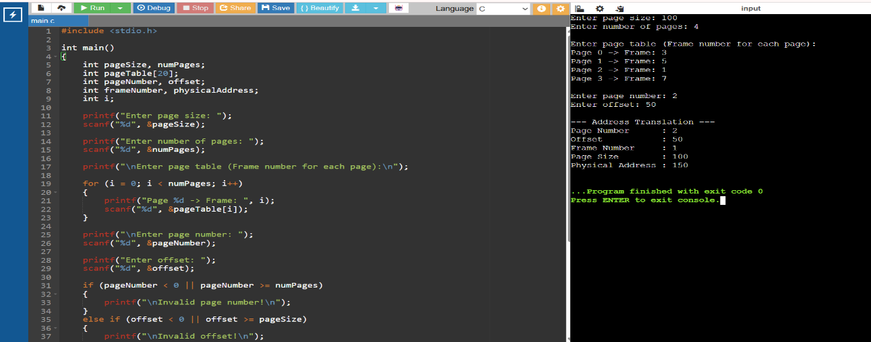
Result
The program successfully demonstrates paging memory management and translates a logical address consisting of a page number and offset into the corresponding physical address using a page table.

Experiment 3: Page Table Simulation

1. Aim
To develop a C program to simulate a page table that accepts page table entries and logical addresses, and maps the page numbers to corresponding frame numbers to calculate physical addresses.
2. Objective
- To understand the working of a page table.
- To map logical page numbers to physical frame numbers.
- To calculate physical addresses.
- To understand page-table-based address translation.
3. Theory
A page table maintains the mapping between a page number in logical memory and a frame number in physical memory.
For a logical address:
Logical Address = Page Number + Offset
The page table translates:
Page Number → Frame Number
Then the physical address is calculated as:
Physical Address = (Frame Number × Page Size) + Offset
Example
If:
Page Size = 100
Page Number = 2
Offset = 25
and the page table contains:
Page 2 → Frame 5
Then:
Physical Address = (5 × 100) + 25
= 525
4. C Program
#include <stdio.h>

int main()
{
int pageTable[20];
int numPages, pageSize;
int i;
int pageNumber, offset;
int frameNumber, physicalAddress;

printf("Enter page size: ");
scanf("%d", &pageSize);

printf("Enter number of pages: ");
scanf("%d", &numPages);

printf("\nEnter page table entries:\n");

for (i = 0; i < numPages; i++)
{
printf("Page %d -> Frame: ", i);
scanf("%d", &pageTable[i]);
}

printf("\n--- Page Table ---\n");
printf("Page Number\tFrame Number\n");

for (i = 0; i < numPages; i++)
{
printf("%d\t\t%d\n", i, pageTable[i]);
}

printf("\nEnter logical address details:\n");

printf("Enter page number: ");
scanf("%d", &pageNumber);

printf("Enter offset: ");
scanf("%d", &offset);

if (pageNumber < 0 || pageNumber >= numPages)
{
printf("\nInvalid Page Number!\n");
}
else if (offset < 0 || offset >= pageSize)
{
printf("\nInvalid Offset!\n");
}
else
{
frameNumber = pageTable[pageNumber];

physicalAddress = (frameNumber * pageSize) + offset;

printf("\n--- Address Translation ---\n");
printf("Page Number : %d\n", pageNumber);
printf("Frame Number : %d\n", frameNumber);
printf("Offset : %d\n", offset);
printf("Physical Address : %d\n", physicalAddress);
}

return 0;
}

OUTPUT:
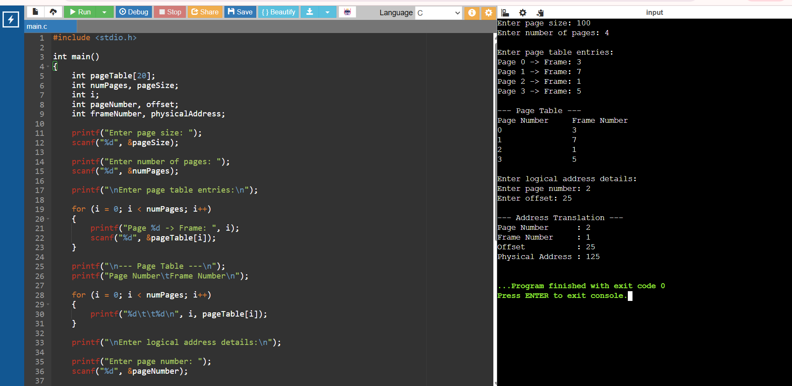

Result
The program successfully simulates a page table and demonstrates how a logical page number is translated into a physical frame number. The corresponding physical address is then calculated using the frame number and offset.

Experiment 4: Translation Lookaside Buffer (TLB)
1. Aim
To implement a C program that simulates the working of a Translation Lookaside Buffer (TLB) and demonstrates how TLB improves memory access time by calculating the Effective Access Time (EAT) with and without TLB.
2. Objective
- To understand the working of TLB.
- To simulate TLB hits and misses.
- To calculate memory access time without TLB.
- To calculate effective memory access time with TLB.
- To compare both access times.
3. Theory
A Translation Lookaside Buffer (TLB) is a small, fast cache that stores recently used page number → frame number mappings.
When the CPU generates a logical address:
- The TLB is checked first.
- If the page number is found, it is a TLB hit.
- If it is not found, it is a TLB miss, and the page table must be accessed.
Without TLB
For every memory reference:
Page Table Access + Memory Access
Therefore:
Memory Access Time = Page Table Time + Memory Time
With TLB
For a TLB hit:
TLB Lookup + Memory Access
For a TLB miss:
TLB Lookup + Page Table Access + Memory Access
4. Effective Access Time Formula
Let:
- T = TLB lookup time
- M = Main memory access time
- H = TLB hit ratio
Then:
Without TLB
EAT = 2M
With TLB
EAT = H(T + M) + (1-H)(T + 2M)
A higher TLB hit ratio generally results in a lower effective access time.

5. C Program
#include <stdio.h>

int main()
{
float tlbTime, memoryTime, hitRatio;
float eatWithoutTLB, eatWithTLB;

printf("Enter TLB lookup time (ns): ");
scanf("%f", &tlbTime);

printf("Enter main memory access time (ns): ");
scanf("%f", &memoryTime);

printf("Enter TLB hit ratio (0 to 1): ");
scanf("%f", &hitRatio);

if (hitRatio < 0 || hitRatio > 1)
{
printf("\nInvalid hit ratio!\n");
return 0;
}

/* Without TLB:
One access to page table + one access to memory */
eatWithoutTLB = 2 * memoryTime;

/* With TLB:
Hit = TLB lookup + memory access
Miss = TLB lookup + page table access + memory access */
eatWithTLB =
hitRatio * (tlbTime + memoryTime)
+ (1 - hitRatio) * (tlbTime + 2 * memoryTime);

printf("\n----- TLB Performance Analysis -----\n");

printf("TLB Lookup Time : %.2f ns\n", tlbTime);
printf("Memory Access Time : %.2f ns\n", memoryTime);
printf("TLB Hit Ratio : %.2f\n", hitRatio);

printf("\nEffective Access Time without TLB : %.2f ns\n",
eatWithoutTLB);

printf("Effective Access Time with TLB : %.2f ns\n",
eatWithTLB);

if (eatWithTLB < eatWithoutTLB)
printf("\nTLB improves memory access time.\n");
else
printf("
\nNo improvement with the given values.\n");

return 0;
}

OUTPUT:
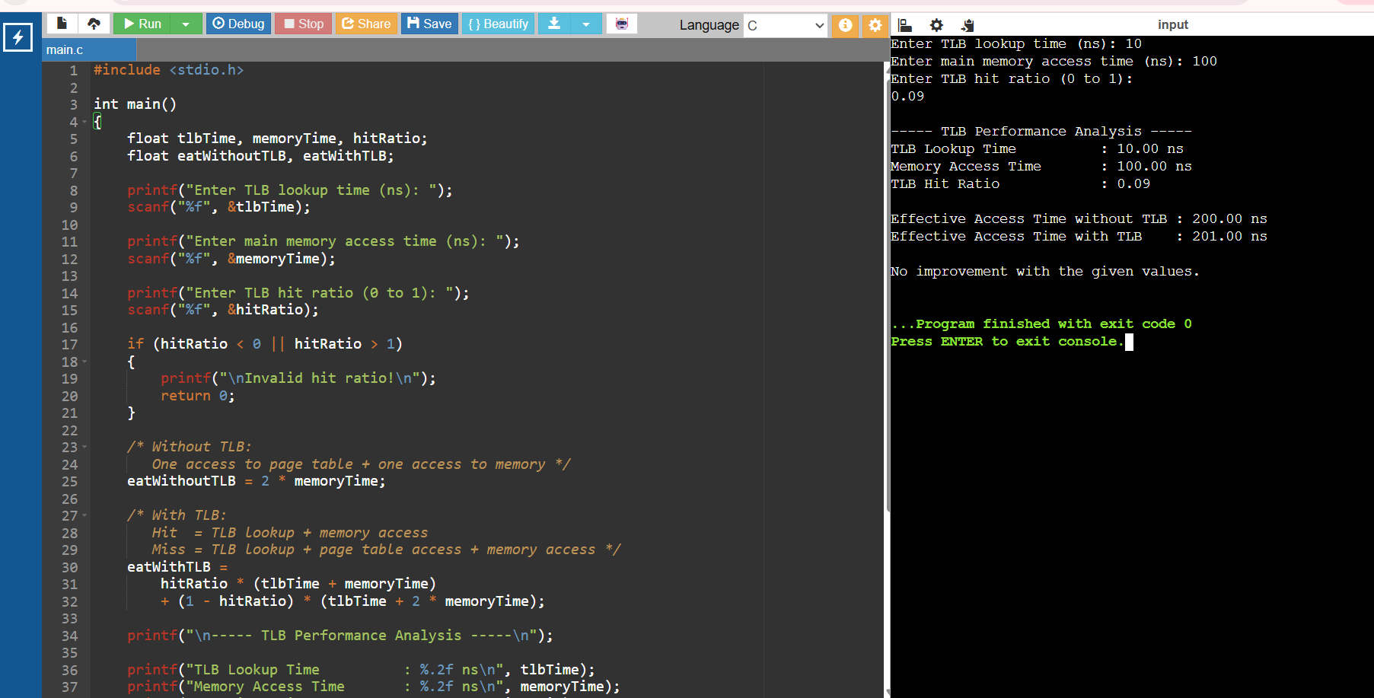

Result
The program successfully simulates a Translation Lookaside Buffer and calculates the effective memory access time with and without TLB. The results demonstrate that a high TLB hit ratio significantly reduces memory access time and improves overall system performance.

Experiment 5: Memory Protection Using Base and Limit Registers

1. Aim
To write a C program to illustrate memory protection using base and limit registers. The program verifies whether a given logical address lies within the valid memory range and prevents unauthorized memory access.
2. Objective
- To understand memory protection.
- To understand the purpose of base and limit registers.
- To validate logical addresses before memory access.
- To calculate the physical address for valid addresses.
- To prevent unauthorized access to memory.
3. Theory
The base register contains the starting physical address of a process in memory.
The limit register specifies the size of the valid logical address space for that process.
The CPU generates a logical address, and the hardware checks it against the limit.
Address Validation
0 ≤ Logical Address < Limit
If the condition is true:
Physical Address = Base + Logical Address
If the condition is false, the memory access is rejected and a protection violation occurs.
Example
Given:
Base = 4000
Limit = 1000
Logical Address = 500
Since:
500 < 1000
the address is valid.
Physical Address = 4000 + 500
= 4500

4. C Program
#include <stdio.h>

int main()
{
int base, limit;
int logicalAddress, physicalAddress;

printf("Enter Base Address: ");
scanf("%d", &base);

printf("Enter Limit: ");
scanf("%d", &limit);

printf("Enter Logical Address: ");
scanf("%d", &logicalAddress);

printf("\n--- Memory Protection Check ---\n");

if (logicalAddress >= 0 && logicalAddress < limit)
{
physicalAddress = base + logicalAddress;

printf("Logical Address : %d\n", logicalAddress);
printf("Base Address : %d\n", base);
printf("Limit : %d\n", limit);

printf("\nAccess Status : ALLOWED\n");
printf("Physical Address : %d\n", physicalAddress);
}
else
{
printf("Logical Address : %d\n", logicalAddress);
printf("Base Address : %d\n", base);
printf("Limit : %d\n", limit);

printf("\nAccess Status : DENIED\n");
printf("ERROR: Unauthorized memory access!\n");
printf("Protection violation detected.\n");
}

return 0;
}

OUTPUT:
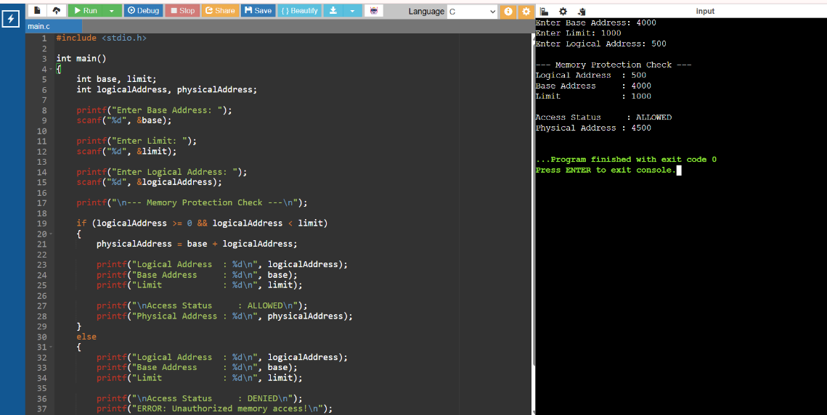
Result
The program successfully demonstrates memory protection using base and limit registers. Valid logical addresses are translated into physical addresses, while addresses outside the permitted range are rejected, thereby preventing unauthorized memory access.

